JOE STREET CHOCOLATE
THE COMFORTS
Rich, creamy, and made for slow or busy days. Your go-to chocolate drinks for comfort, cravings, and everything in between.

HOT CHOCOLATE
Drink | Description | Price
Hot Chocolate | Rich, smooth, and comforting, like your favourite chocolate served warm. | ₱79
Hot Mocha | Chocolate with a coffee kick. Bold, creamy, and made for long days. | ₱89

ICED CHOCOLATE
Drink | Description | Price
Iced Chocolate | Cold, creamy, and made for chocolate cravings. Simple, smooth, and always a good idea. | ₱89
Iced Chocolate Latte | Cold, creamy, and perfectly balanced with chocolate and milk in every sip. | ₱99
Iced Choco Oreo | Creamy chocolate blended with crushed Oreo goodness, sweet, fun, and hard to share. | ₱115
Iced Choco Strawberry | Chocolate and strawberry, the perfect sweet pair in one refreshing cup. | ₱115

A place you can come back to.

JOE STREET CHOCOLATE BUILD GUIDE

STANDARD CHOCOLATE BASE
- Make chocolate base first by dissolving chocolate powder in 50ml water with crushed ice before adding milk.
- Make sure there are no powder lumps before pouring into the cup.
- For iced drinks, use mixed ice at 80 to 85% cup level and serve immediately.
- Use more solid ice maker ice first, then crushed ice only to fill gaps.
- Always wall with chocolate syrup.

CHOCOLATE BUILDS

Hot Chocolate — ₱79
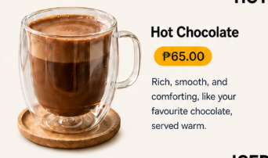  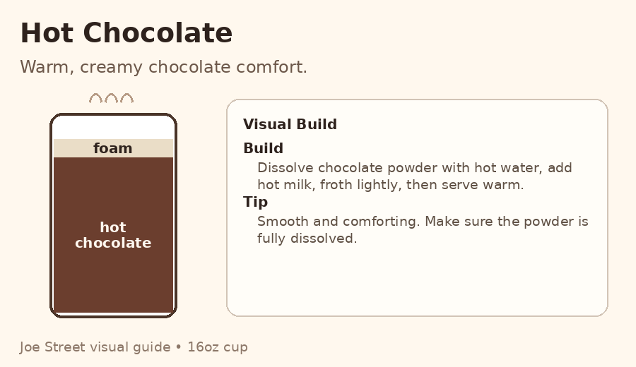 | Ingredients  • ¼ cup chocolate powder  • 30ml hot water  • 160ml hot milk  • Light milk foam, optional  Build  1. Dissolve chocolate powder in hot water.  2. Add hot milk.  3. Mix until smooth.  4. Top with light milk foam if available.  5. Serve immediately.  Staff Note  This should taste smooth, creamy, and comforting. Do not serve with powder lumps.

Hot Mocha — ₱89
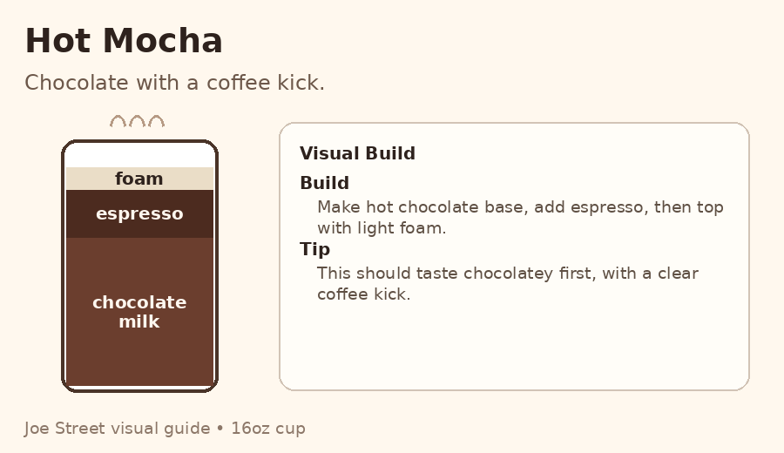  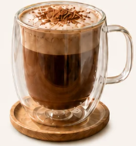 | Ingredients  • ¼ cup chocolate powder  • 30ml hot water  • 120ml hot milk  • 45ml espresso  • Light milk foam, optional  Build  1. Dissolve chocolate powder in hot water.  2. Add 45ml espresso.  3. Pour hot milk.  4. Mix lightly.  5. Top with light foam if available.  6. Serve immediately.  Staff Note  Chocolate should still be the main taste, with coffee as the kick.

Iced Chocolate — ₱89
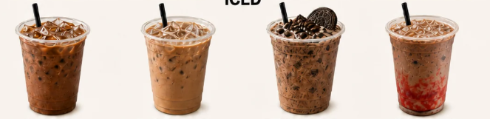  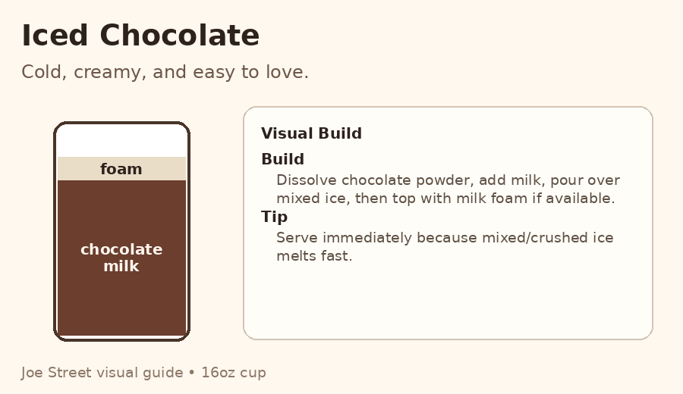 | Ingredients  • ¼ cup chocolate powder and  • 1 tbsp powdered milk  • 80 to 85% cup ice  Build  1. Froth chocolate and milk powder in Biolomix with 50ml water and 2tbsp crushed ice.  2. Wall the cup with chocolate syrup.  3. Fill cup 80 to 85% with ice.  4. Add chocolate mix  5. Stir lightly or shake if needed.  7. Add chocolate syrup on top. Serve immediately.  Staff Note  This is the simple cold chocolate option. Keep it creamy and not watery.

Iced Chocolate Latte — ₱99
  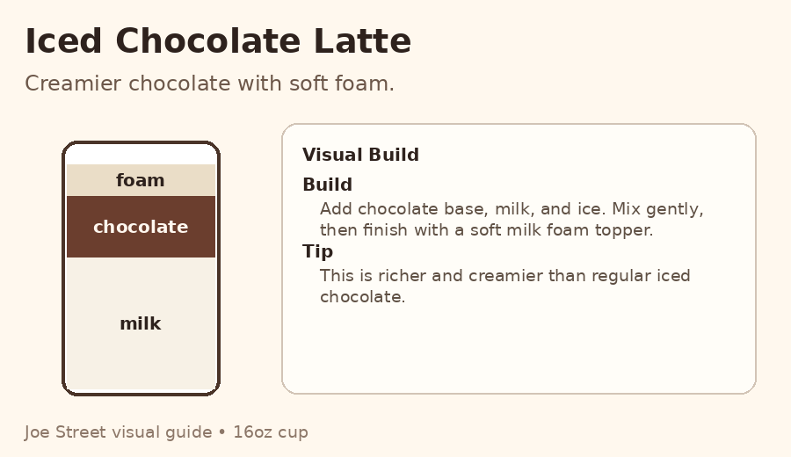 | Ingredients  • ¼ cup chocolate powder and  • 1 tbsp powdered milk  • 80 to 85% cup ice  • Milk foam Kreem Puff topper  Build  1. Froth chocolate and milk powder in Biolomix with 50ml water and 2tbsp ice.  2. Froth the milk foam  2. Wall the cup with chocolate syrup.  3. Fill cup 80 to 85% with ice.  4. Add chocolate mix  5. Stir lightly or shake if needed.  7. Top with milk foam. Serve immediately.  Staff Note  This is creamier and more premium than the regular iced chocolate.

Iced Choco Oreo — ₱115
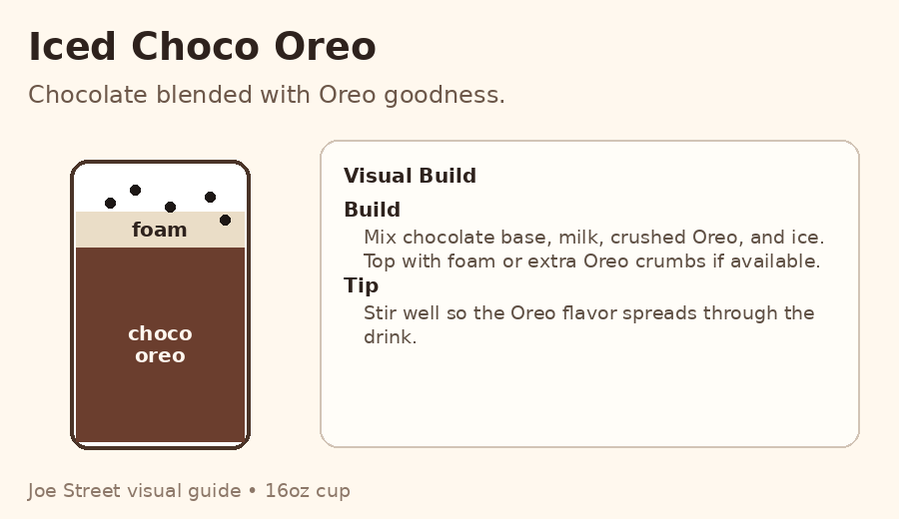   | Ingredients  • ¼ cup chocolate powder  • 2 tbsp oreo powder  • 1 tbsp powdered milk  • 80 to 85% cup ice  • Crushed Oreo, oreo cookie, hello, chocolate chips  Build  1. Froth chocolate and milk powder in Biolomix with 50ml water and 2tbsp ice.  2. Froth the milk foam  2. Wall the cup with chocolate syrup.  3. Fill cup 80 to 85% with ice.  4. Add chocolate mix  5. Stir lightly or shake if needed.  7. Top with Oreo cookie, crushed oreo, chocolate bar, and chocolates. Serve immediately.  Staff Note  Make sure Oreo is crushed small enough for easy drinking.

Iced Choco Strawberry — ₱115
  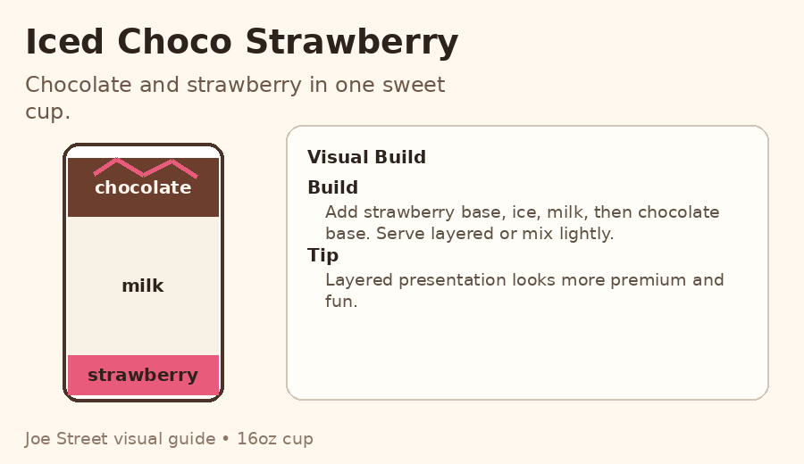 | Ingredients  • 20ml strawberry jam  • ¼ cup tbsp chocolate powder  • 50ml water  • 1 tbsp powdered milk  • 80 to 85% cup ice  • Milk foam topper  Build  1. Add strawberry syrup or base at the bottom of the cup.  2. Froth the milk foam  3. Fill cup 80 to 85% with ice.  4. Add chocolate mix  5. Stir lightly or shake if needed.  6. Add the milk foam.  7. Serve immediately.  Staff Note  Layered presentation looks more premium. Let customer mix before drinking if served layered.

